PIXEL FORGE
UI Guide: layouts, controls and known layout problems
Purpose: a complete description of Pixel Forge's current desktop user interface, written so another AI assistant (e.g. Gemini) or a designer can propose and implement UI fixes without breaking behaviour.
App: Pixel Forge, an offline desktop app that turns images into 16x16 / 32x32 pixel art (Python 3.13, Tkinter/ttk, Pillow). Windows 11.
State documented: 24 September 2026. Screenshots were captured from the running app at its default size (1140x800) and minimum size (900x720).

Contents
1. Brief for the assistant 2
What to deliver 2
Hard constraints 2
2. What the app does 3
Empty state 3
3. Window layout 4
Widget tree (pack/grid structure) 5
4. Sidebar controls 6
5. Pixel Art views 7
5.1 Sprite view (default) 7
5.2 Edit view: painting and layers 7
5.3 In-game view 8
6. Theme 9
ttk styles in use 9
Spacing now 9
7. Keyboard and mouse 10
8. Minimum window size (900 x 720) 11
9. Known UI problems (please fix) 13
10. Code map 14
11. Names the tests rely on 15

1. Brief for the assistant
You are being asked to improve the layout and visual polish of an existing Tkinter desktop app. The app works; the goal is a cleaner, more consistent UI that never clips or squashes controls, especially at the minimum window size.

What to deliver
- Concrete code changes to pixel_forge.py and editor_ui.py (the only files that build UI), as full replacement functions or clear diffs.
- A short rationale per change, referencing the region numbers used in this document.
- Keep changes incremental: fix the problems in section 9 first, then optional polish.

Hard constraints
- Toolkit: Tkinter + ttk (theme clam) and Pillow only. No new dependencies (no customtkinter, PyQt, web views).
- Windows 11, per-monitor DPI aware (the app calls SetProcessDpiAwareness(1)). Default window 1140x800, minimum 900x720 (logical px).
- Pixel art must stay crisp: sprites are only ever enlarged by whole-number factors with NEAREST resampling. Don't place the art where it would be scaled by a fractional factor.
- Keep every feature and shortcut listed in sections 4, 5 and 7; relabelling or regrouping is fine.
- Keep the widget attribute names in section 11 (automated UI tests use them) or list any renames explicitly.
- Keep the dark 'arcade' look (section 6) unless proposing a clearly better palette with the same token names.

2. What the app does
Pixel Forge converts a picture (JPG/PNG) into a small pixel-art sprite, typically a 16x16 Minecraft item texture. Typical workflow:
- Open an image (Ctrl+O). The ORIGINAL panel shows it with a dashed cyan box marking the square that becomes the sprite.
- Tune the sidebar: grid size, colour limit, sprite clean-up, outline and detail lines, background removal (plain or AI), zoom-to-fit, transparency, scale and position.
- Review in the PIXEL ART panel. Three views: Sprite (the result), Edit (paint with layers and blend modes), In-game (a Minecraft inventory mock-up).
- Optionally press Match Original to re-fit colours to the source, and paint fixes in Edit view.
- Save the enlarged art (512x512) or the raw sprite (e.g. 16x16), optionally straight into a remembered export folder.

Empty state
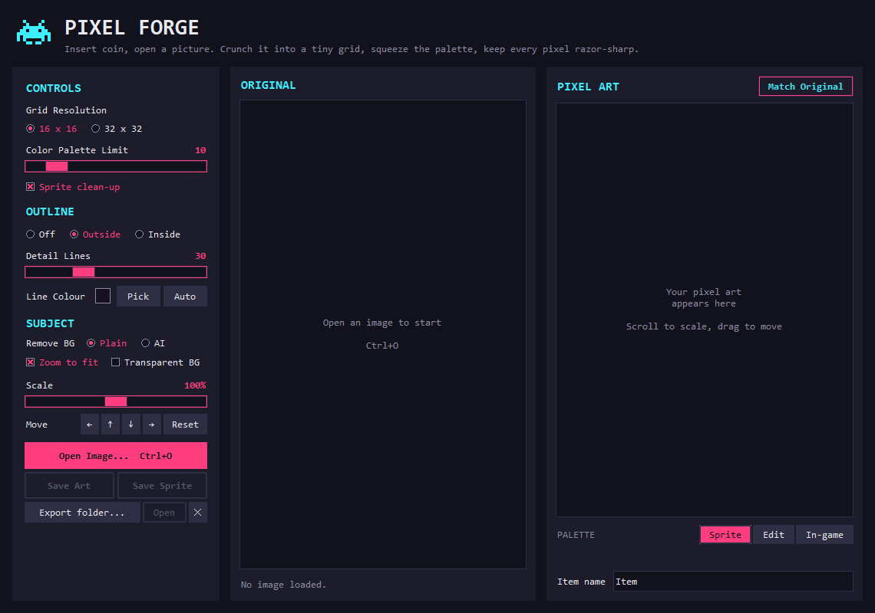
Figure 1. First launch, before an image is opened (1140x800).

3. Window layout
The window is a fixed three-column layout inside a 16 px outer margin: a header across the top, a fixed-width sidebar on the left, and two equal-width panels (ORIGINAL and PIXEL ART) sharing the remaining width.
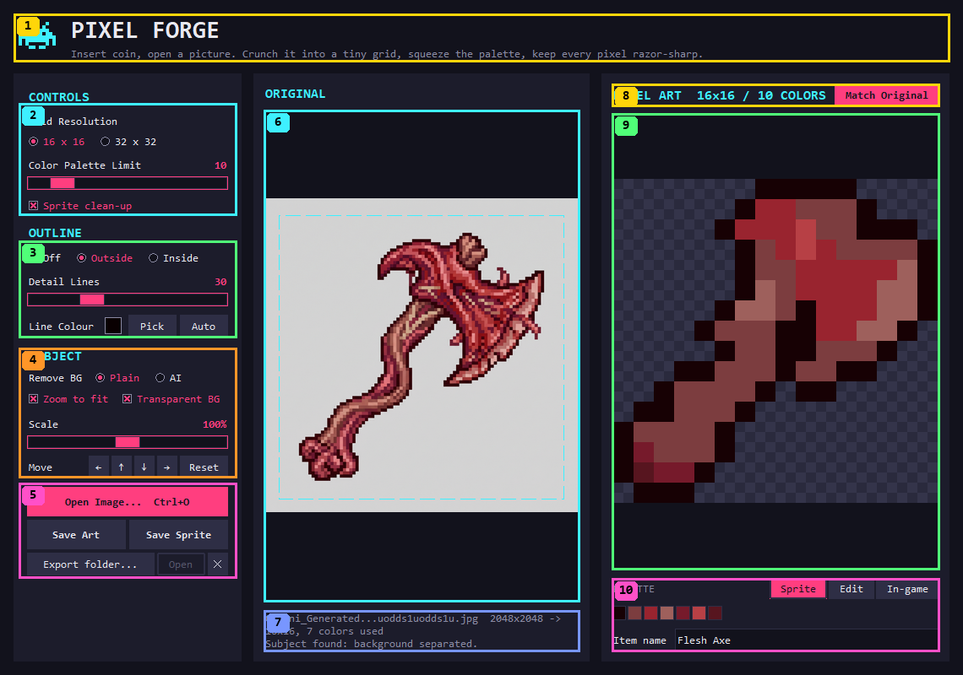
Figure 2. Default size (1140x800), Sprite view. Numbers match the table below.
# | Region | What's in it | Size now (px)
1 | Header | Invader logo, PIXEL FORGE title (Consolas 22 bold), tagline. | 1108 x 57
2 | Sidebar: CONTROLS | Grid Resolution radios (16x16 / 32x32), Color Palette Limit slider (2-64) with value, Sprite clean-up checkbox. | 258 x 133
3 | Sidebar: OUTLINE | Off / Outside / Inside radios, Detail Lines slider (Off-100), Line Colour swatch + Pick + Auto. | 258 x 115
4 | Sidebar: SUBJECT | Remove BG radios (Plain / AI), Zoom to fit + Transparent BG checkboxes, Scale slider (50-150%), Move arrows + Reset. | 258 x 154
5 | Sidebar: files | Open Image (accent), Save Art + Save Sprite, export folder row (path button, Open, clear). | 258 x 113
6 | ORIGINAL canvas | The source image fitted to the panel (smooth scaling), checkerboard behind transparency, dashed cyan crop box. | 374 x 583
7 | Status text | File name, sizes, colours used, scale/offset, detection result, layer notes. Wraps to the panel width. | 374 x 49
8 | PIXEL ART header | Title with grid and colour count, Match Original button (accent; shows 'Matched' when done). | 388 x 27
9 | PIXEL ART canvas | The sprite enlarged by a whole number, checkerboard behind transparency. Drag = move subject, wheel = scale. | 388 x 541
10 | Footer | PALETTE label + Sprite / Edit / In-game switch, palette swatches (most-used first), Item name field (tooltip + export file name). | 388 x 87

Widget tree (pack/grid structure)
Indentation is nesting; the geometry manager used is in brackets. Built in PixelForgeApp._build / _build_sidebar / _panel (pixel_forge.py) and LayerEditorMixin._build_editor_ui (editor_ui.py).
root (Tk) 1140x800, min 900x720, bg #12121c
└ outer Frame Bg.TFrame, padding 16 [pack fill=both expand]
├ header Frame [pack fill=x, pady=(0,14)]
│ logo Label (invader image) · title Label · tagline Label
└ body Frame [pack fill=both expand]
├ side Frame Panel.TFrame, padding 16, width 270, [pack side=left fill=y]
│ pack_propagate(False) ← fixed width; content that doesn't fit is CLIPPED
│ CONTROLS: Head label, radio row, _slider(colours), clean-up checkbox
│ OUTLINE: Head label, radio row, _slider(detail), Line Colour row
│ SUBJECT: Remove BG row, checkbox row, _slider(scale), Move row
│ Open Image button · saves Frame [grid 2 cols] · export row
└ panels Frame [pack side=left fill=both expand, padx=(14,0)]
(columns 0 and 1: weight=1, uniform — always equal width)
├ ORIGINAL panel Frame Panel.TFrame, padding 12 [grid col 0, padx=(0,14)]
│ header Frame (title) [pack fill=x]
│ orig_canvas (tk.Canvas) [pack fill=both expand]
│ status Label (wraplength = panel width - 24) [pack side=bottom]
│ layer_panel Frame (Edit view only) [pack side=bottom, above status]
└ PIXEL ART panel Frame Panel.TFrame, padding 12 [grid col 1]
header Frame: title Label + match_btn [pack fill=x]
toolbar Frame (Edit view only) [pack fill=x, before canvas]
art_canvas (tk.Canvas) [pack fill=both expand]
footer Frame [pack side=bottom fill=x]
top row: footer_label + view switch (3 Seg.Toolbutton radios, packed right)
palette_canvas (hidden in In-game view) · name_row (Item name Entry)

4. Sidebar controls
Every control re-renders the sprite live (debounced 10-60 ms). Defaults are tuned for 16x16 sprites.
Control | Widget / style | Default | Behaviour
Grid Resolution | 2 x TRadiobutton | 16 x 16 | Sprite size. Painted layers are rescaled (NEAREST) when it changes.
Color Palette Limit | ttk.Scale 2-64 + Value.TLabel | 10 | Max colours in the sprite, counting the outline and a flat background colour.
Sprite clean-up | TCheckbutton | on | Majority-colour downscale, k-means palette, despeckle, pixel-perfect outline.
Outline | 3 x TRadiobutton | Outside | Off / Outside (around the subject) / Inside (on its edge pixels).
Detail Lines | ttk.Scale 0-100 | 30 | Darker lines between contrasting regions. Label shows 'Off' at 0.
Line Colour | tk.Canvas swatch + Pick + Auto (Small.TButton) | Auto | Auto = dark shade of the sprite's own colours; Pick opens the colour chooser.
Remove BG | 2 x TRadiobutton | Plain | Plain = flood fill from a plain border. AI = rembg on a worker thread (shows progress text).
Zoom to fit | TCheckbutton | on | Crop to the subject so it fills the grid (1 px margin kept for the outline).
Transparent BG | TCheckbutton | off | Remove the background instead of flattening it to one colour.
Scale | ttk.Scale 50-150 % | 100% | Subject size in the grid. Also mouse wheel on the sprite, Ctrl+= / Ctrl+-.
Move | 4 x Arrow.TButton + Reset | 0, 0 | Nudge the subject 1 art pixel. Also drag on the sprite, Ctrl+arrows; Reset = Ctrl+0.
Open Image... | Accent.TButton |  | Ctrl+O. Asks first if there are unsaved layers/edits.
Save Art / Save Sprite | TButton pair (grid) | disabled until an image is open | Ctrl+S / Ctrl+Shift+S. 512x512 enlarged art / raw sprite. Uses all visible layers combined.
Export folder row | Small.TButton (path) + Open + clear | not set | When set, saves go straight there as <item_name>.png / <item_name>_512.png; remembered in %APPDATA%\PixelForge\settings.json.

5. Pixel Art views
The footer switch changes what the PIXEL ART panel shows. Sprite and Edit keep the palette swatches visible; In-game hides them.

5.1 Sprite view (default)
See Figure 2. The sprite is enlarged by the largest whole number that fits (NEAREST), centred, over a checkerboard. Mouse: drag moves the subject by whole art pixels, wheel scales it.

5.2 Edit view: painting and layers
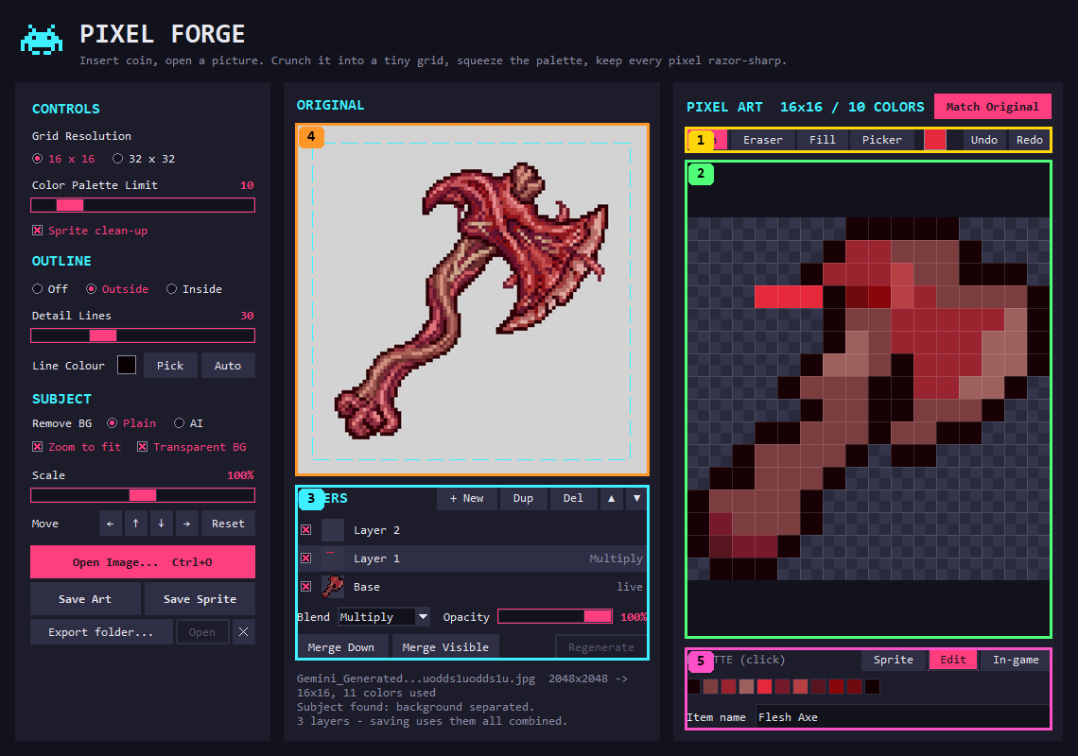
Figure 3. Edit view with three layers (1140x800).
# | Region | Contents and behaviour
1 | Toolbar | Pen / Eraser / Fill / Picker as Seg.Toolbutton radios (keys B, E, G, I), current paint colour swatch (click = colour chooser), Undo / Redo (Ctrl+Z, Ctrl+Y or Ctrl+Shift+Z).
2 | Edit canvas | Composite of all visible layers, faint pixel grid when zoom >= 6, cyan outline on the hovered pixel. Left = tool, right = erase, drag paints continuous lines.
3 | Layers panel | Header: LAYERS + New, Dup, Del, up, down. One row per layer (top first): visibility checkbox, 24 px thumbnail, name (double-click renames), tags (live / edited, blend mode, opacity). Blend combobox (11 modes) + Opacity slider. Merge Down, Merge Visible, Regenerate. Max 8 layers.
4 | ORIGINAL canvas | Still shown for reference, but shrinks to make room for the layers panel.
5 | Footer | Label reads 'PALETTE (click)': clicking a swatch picks that colour and switches to Pen.
Base layer rules: the generated sprite is the bottom 'Base' layer and stays live (follows settings) until painted on or merged into; then it's 'edited' (frozen) and Regenerate restores the live version. The status line explains this when it happens.

5.3 In-game view
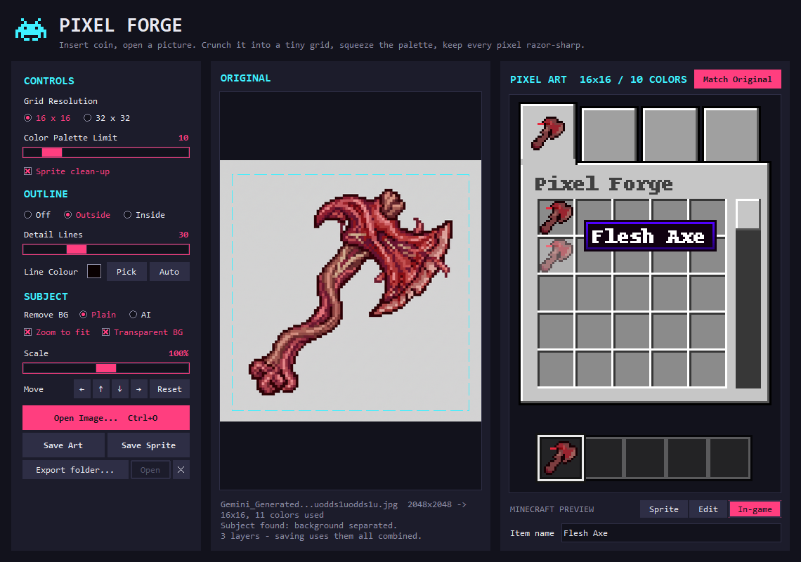
Figure 4. In-game view: a Minecraft-style creative inventory drawn from scratch (tab icon, slot with hover + tooltip, hotbar).
The mock-up is enlarged by a whole-number GUI scale (up to 4x) and shows fewer inventory columns/rows when the panel is narrow so the icon stays readable. If the sprite has no transparency, a tip below it suggests ticking Transparent BG.

6. Theme
Defined at the top of pixel_forge.py (mirrored in editor_ui.py). ttk theme: clam, restyled.
Token | Value |  | Used for
BG | #12121c |  | Window background, canvas backgrounds, entry fields
PANEL | #1c1c2b |  | Sidebar and panel backgrounds
BORDER | #2e2e45 |  | Borders, normal buttons, selected layer row, segmented buttons
TEXT | #e8e8f0 |  | Primary text
MUTED | #8a8aa3 |  | Secondary text, status, tagline, radio/check borders
ACCENT | #ff3e7f |  | Hot pink: primary buttons, selected radios/checks/segments, slider handles, values
ACCENT_HI | #ff6b9d |  | Hover state of accent elements
CYAN | #3ef0ff |  | Section headings, crop box, hover outline, 'Matched' label
checker | #2a2a3d / #34344a |  | Checkerboard behind transparent pixels

Font token | Value | Used for
FONT | Consolas 10 | Body text, labels, small buttons
FONT_BOLD | Consolas 10 bold | Buttons, slider values
FONT_HEAD | Consolas 12 bold | Section headings (CONTROLS, OUTLINE, SUBJECT, ORIGINAL, PIXEL ART, LAYERS)
FONT_TITLE | Consolas 22 bold | PIXEL FORGE title

ttk styles in use
Accent.TButton, Small.TButton, Arrow.TButton, Match.TButton, TButton, Seg.Toolbutton (segmented radios), TRadiobutton, TCheckbutton, Horizontal.TScale, TCombobox, TLabel variants (Head, Muted, Value, Title, Tagline, Bg), Frame variants (Bg, Panel), and layer-row styles Row / RowSel / RowMuted (editor_ui.py).

Spacing now
- Outer margin 16; header bottom gap 14; gap between columns 14; panel padding 12; sidebar padding 16, fixed width 270.
- Section headings: 10 px above, 4-6 below. Slider rows 8 px above. Buttons: TButton padding (10, 7), Small (8, 3), Arrow (2, 3).
- Spacing has been tuned by hand to fit 720 px height; it's not on a consistent scale (a known issue).

7. Keyboard and mouse
Input | Where | Action
Ctrl+O | anywhere | Open image
Ctrl+S / Ctrl+Shift+S | anywhere | Save Art / Save Sprite
Ctrl+M | anywhere | Match Original
Ctrl+arrows, Ctrl+= / Ctrl+-, Ctrl+0 | anywhere | Move subject, scale it, reset
Ctrl+Z / Ctrl+Y / Ctrl+Shift+Z | not in text fields | Undo / redo (layer edits)
B, E, G, I | Edit view, not in text fields | Pen, Eraser, Fill, Picker
Drag / wheel | Sprite view canvas | Move subject / scale subject
Left / right drag | Edit view canvas | Paint with the tool / erase
Click swatch | Edit view footer | Pick that colour
Double-click layer name | Layers panel | Rename layer
Drop image on Pixel Forge.exe | Explorer | Opens the app with that image

8. Minimum window size (900 x 720)
The sidebar keeps its fixed 270 px, so everything else shrinks: the two panels get about 280 px each. This is where most layout problems appear.
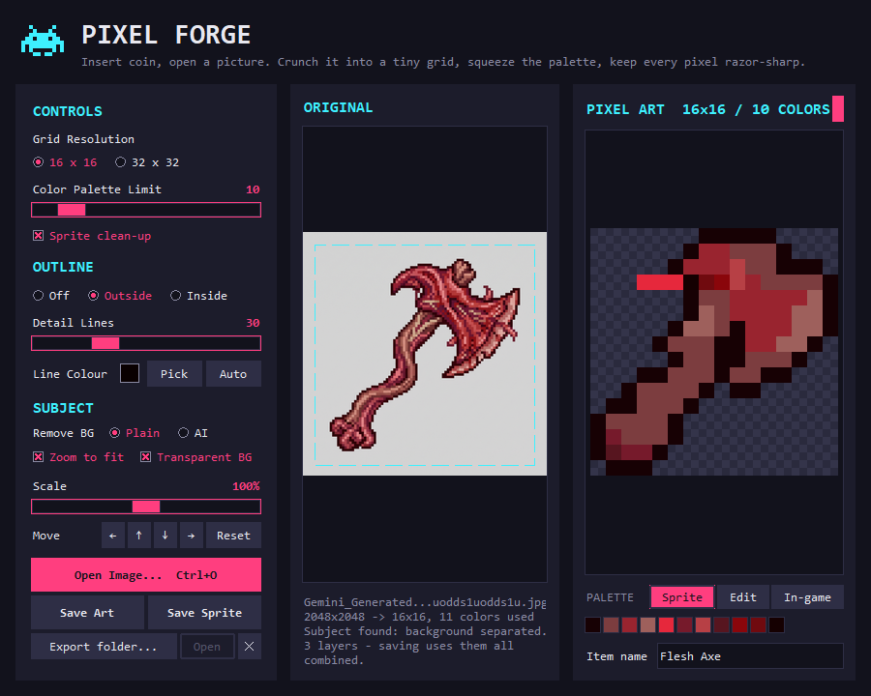
Figure 5. Minimum size, Sprite view.
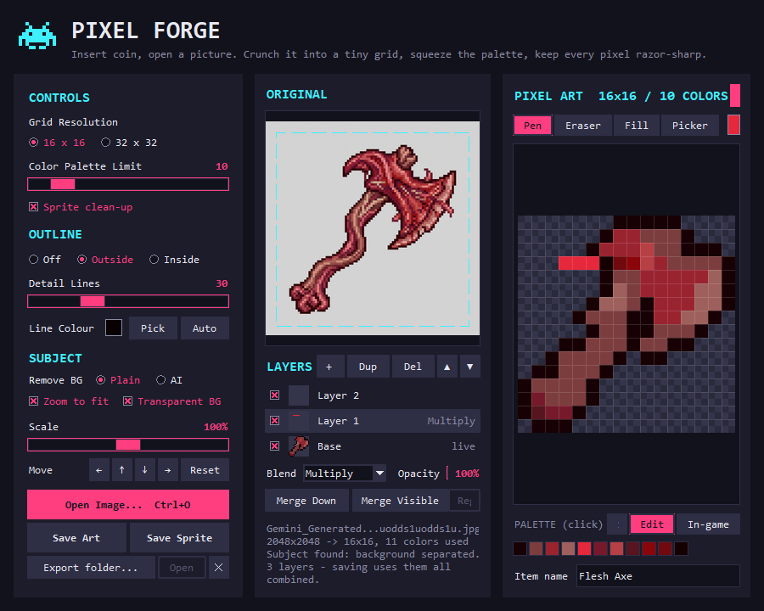
Figure 6. Minimum size, Edit view: the tightest layout. Several controls are clipped or squashed (see section 9).

9. Known UI problems (please fix)
Found by inspecting the screenshots above. Ordered by severity.

A. Controls clipped or squashed at the minimum size (Figure 6)
- Match Original button (PIXEL ART header) collapses to a thin pink sliver: the title 'PIXEL ART 16x16 / 10 COLORS' takes the width first.
- Edit toolbar: Undo and Redo are pushed out of view; the colour swatch is cut off.
- Layers panel: the Opacity slider collapses to a few pixels; 'Regenerate' is truncated ('Re|').
- Footer view switch: the 'Sprite' button is squeezed to nothing next to the 'PALETTE (click)' label.
- Root cause: pack-based rows with no minimum widths or wrapping; the sidebar's fixed width plus two equal panels leaves ~280 px per panel.

B. Sidebar can't grow and has no scrolling
- The sidebar is a fixed 270 x (window height) frame with pack_propagate(False). Every new control required shaving spacing by hand to keep it inside 720 px; anything taller is silently clipped at the bottom.
- Consider: collapsible sections, a scrollable sidebar, or moving rarely-used options (line colour, export folder) into a secondary area.

C. Edit view squeezes the reference image
- The layers panel is packed into the ORIGINAL panel, so the source image shrinks a lot (Figure 6). A dedicated layers column/drawer, or tabs for Original / Layers, might work better.

D. Status text is long and variable
- Up to 5 wrapped lines at minimum size (file name, sizes, detection, layer notes). It pushes the original image up and is hard to scan. Consider a single-line status bar plus an info tooltip or an expandable details area.

E. Inconsistent visual rhythm and affordances
- Spacing values vary (4, 6, 8, 10, 12, 14, 16) without a scale; section headings and rows don't align between sidebar and panels.
- Several small text buttons (Pick, Auto, Open, Dup, Del, Undo, Redo) have no icons or tooltips; the clear-folder button is only a ✕.
- Sliders have no numeric entry; values are only shown as labels.
- Two header rows compete: the app header (Figure 2, #1) takes ~70 px of height that the canvases could use.

F. Minor
- Long generated file names are shortened with '...' in the status; the export folder path is shown truncated from the left.
- The header logo is the space invader, while the app/launcher icon is now a pixel anvil (Forge).

10. Code map
File | UI responsibilities
pixel_forge.py | Theme constants and ttk styles (_style), window + header + panels (_build), sidebar (_build_sidebar, _radio_row, _slider), panels (_panel), bindings (_bind_keys), view switch (_on_view), drawing (_draw_original, _draw_art, _draw_game_preview, _draw_palette), status (_update_status), export row (_show_export_dir).
editor_ui.py | Edit view (LayerEditorMixin): toolbar + layers panel (_build_editor_ui), show/hide (_show_editor), layer rows (_refresh_layer_panel, _layer_row), edit canvas (_draw_editor), painting handlers.
mc_preview.py | In-game mock-up image (render_inventory, best_fit). Pure Pillow, no Tk.
pixel_core.py, layers.py | Image processing and layer compositing. No UI; don't change for layout work.

11. Names the tests rely on
Automated UI tests drive the real window through these PixelForgeApp attributes and methods. Keep them (or report renames):
Kind | Names
Widgets | scale (colour slider), colors_label, detail_scale, detail_label, size_scale, size_label, swatch, match_btn, art_title, art_canvas, orig_canvas, palette_canvas, name_row, status, save_btn, save_raw_btn, export_btn, open_dir_btn, toolbar, layer_panel, layer_rows, colour_swatch, blend_box, opacity_scale, opacity_label, _layer_buttons['add'|'dup'|'delete'|'up'|'down'|'merge'|'merge_all'|'regen']
Tk variables | grid_var, colors_var, enhance_var, outline_var, detail_var, fit_var, transparent_var, scale_var, bg_method, view_var ('sprite'|'edit'|'game'), item_name, tool_var
Methods | load_image, process, save, save_dialog, choose_export_dir, set_export_dir, clear_export_dir, match_original, nudge, set_scale, reset_transform, _on_view, _on_wheel, _on_drag_start/_on_drag/_on_drag_end, _settings_changed, add_layer, duplicate_layer, delete_layer, move_layer_up/down, merge_layer_down, merge_visible_layers, regenerate_base, set_visible, set_blend_mode, _on_opacity, rename_layer, undo, redo, set_paint_colour, _tool_key, _art_origin (canvas origin + zoom)

Screenshots: the PNGs used here are also in docs/ui-screenshots/ next to this document, at full resolution.

